Everyone has had a time when they have made plans based on a weather forecast of 28°C and sunny, only to be disappointed by an overcast and windy 15°C day. But it is difficult to tell if this is a memory bias, or if the weather forecast really is as bad as we think it is. To test this, I constructed a data pipeline, primarily using AWS, to monitor forecasted and measured weather in Prague, which feeds a live PowerBI dashboard to compare forecast accuracy with different time horizons.
The pipeline uses a Lambda function to ingest the weather data from an API and store it as a .json file in an S3 bucket. A second Lambda function reads the .json files from the S3 bucket and writes the contents to a RDS PostgreSQL database. Finally, a Power BI dashboard is connected to the database so the predicted and measured weathers can be compared.
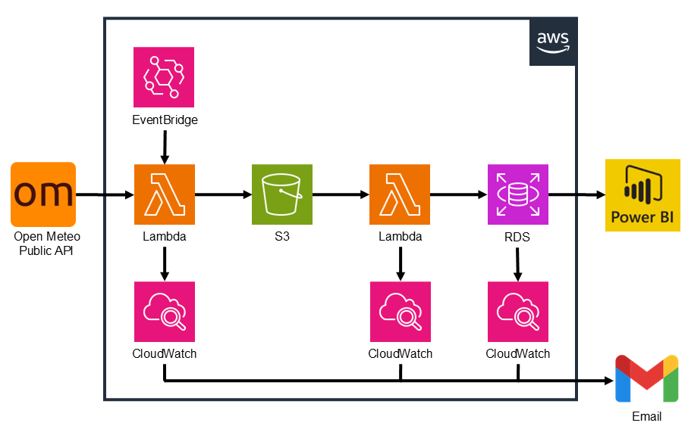
The following services and tools are used:
- AWS EventBridge: To trigger the pipeline at regular intervals
- AWS Lambda: To run python scripts to read, process and save the data
- AWS S3: For temporary storage of the data
- AWS RDS: For long-term storage of the data
- pgAdmin: To access and monitor the RDS database
- Power BI: To create a dynamic dashboard using the data
- AWS CloudWatch: For error handling and alerts
- AWS IAM: To manage permissions
A high-level overview of the pipeline will be given here. For more technical details, and the Python and SQL code used, see the github repo here.

Open Meteo
Open Meteo is a free, publicly accessible weather API, which was used to fetch weather data for Prague, Czechia. It was chosen for this project due to its generous free tier, wide range of weather parameters, and availability of past, present and future data with hourly resolution.
The Open Meteo API does not require a key to access, although securely accessing an API with a key could be easily done using AWS Secrets Manager.
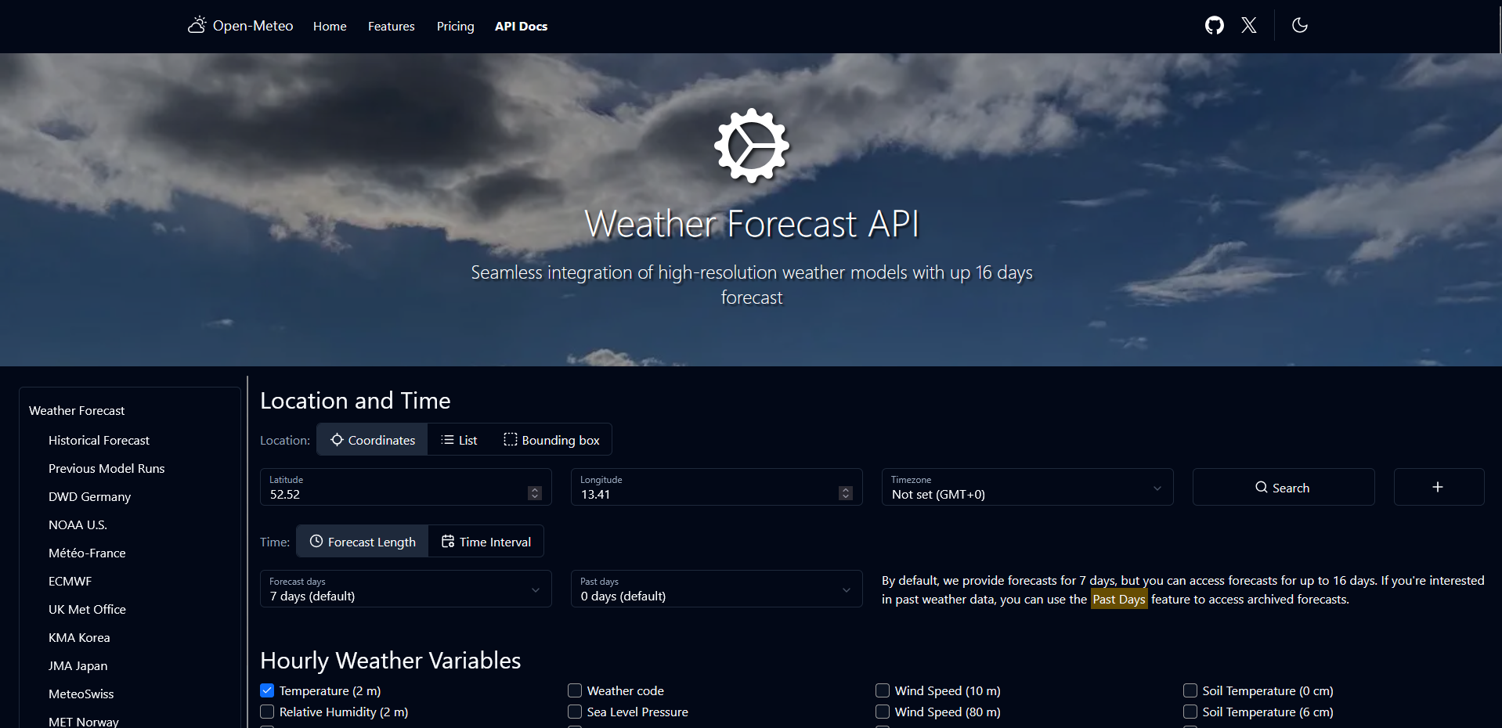

Lambda function 1: API to .json file
The first Lambda function is triggered four times daily, at 00:05, 06:05, 12:05 and 18:05, using a cron expression in EventBridge. A python script is used to request data from the API for the current weather, and hourly predicted weather for the next seven days. This data contains the temperature, precipitation, humidity, wind speed and pressure. The predicted weather data is filtered to only include the predicted weather for 6 hours, 24 hours (1 day), 72 hours (3 days) and 144 hours (6 days) from the current time. The current and filtered predicted weather data are converted into a json string, which is saved as a .json file in an S3 bucket.

S3 Bucket
An S3 bucket is used to temporarily store .json files for use with the second lambda function. After 7 days, the files are deleted to prevent unnecessary storage costs.
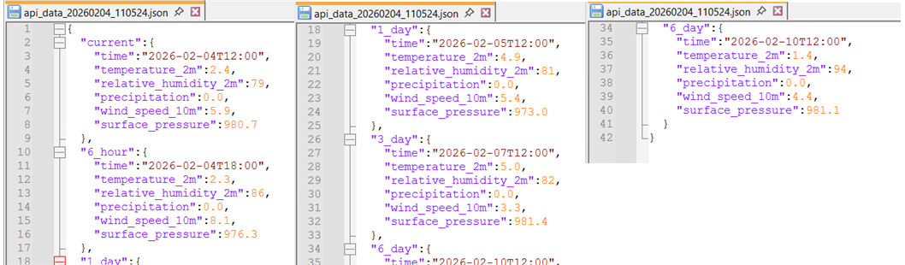

Lambda function 2: json file to RDS database
The second Lambda function is triggered whenever a new .json file is put in the S3 bucket (either by the first Lambda function or manually). In python, the file is verified to ensure it contains the expected data and returns an error if it does not. A connection to the PostgreSQL database is established using the psycopg2 package, and the data is inserted into the correct tables.
It would be possible to combine the two Lambda functions, so that they read the data from the API, validate it and write directly to the database. However, this would increase the vulnerability of the pipeline, as it would fail if either the API or the RDS database failed to connect. By splitting the pipeline into two functions, the steps of the pipeline can run asynchronously, adding resilience in the event of a failure.

RDS database
The RDS PostgreSQL database contains five tables, one for the current weather data, and one for each of the predicted data sets. Each of these tables has the exact same format, with the time of the measurement of prediction, the five weather parameters, a unique id number and a timestamp for when the data was imported into the database.
Security was set on the database, such that it could only be accessed using the lambda function, PowerBI, or from my home IP address.
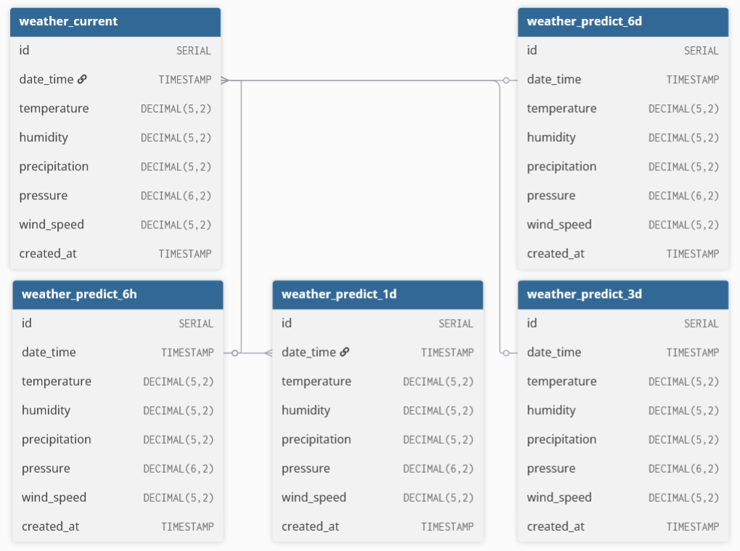

Error Handling and Alerts
In the event of an error, CloudWatch alerts are set up on the Lambda functions, to send an email alert to my personal email address. The Logging module of Python is used in both functions so that when errors occur, they can be debugged using the CloudWatch logs.
The most likely cause of an error is a refused connection, either to the API in the first Lambda function, or to the RDS database in the second Lambda function. By default, a Lambda function will attempt to run the script two more times after an error. In the three weeks since the pipeline was initialised, there have been 2 alerts where the API connection was initially refused but connected on the second attempt. If the script fails three times, I can manually fetch the missed data and insert it into the database.
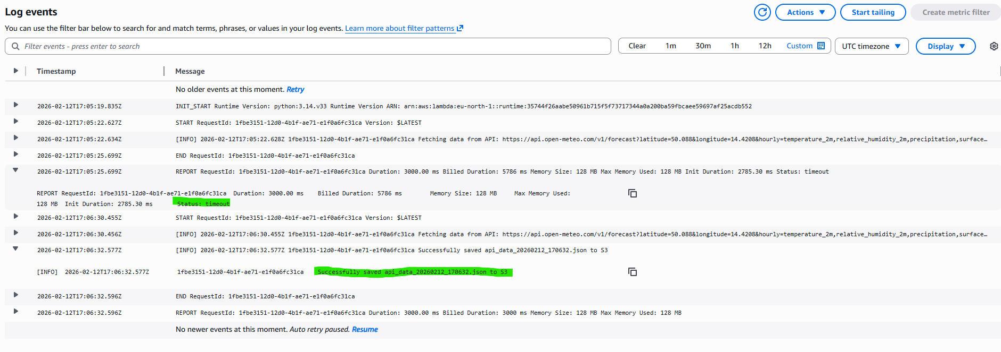
Furthermore, a CloudWatch alert is set up to send a notification email if the available space on the RDS database is less than 2 GB, so action can be taken.

Power BI
Finally, a Power BI dashboard is connected to the database, and the differences in the predicted and actual weather can be compared. As was expected, the 6-hour predictions are very accurate, and become less accurate for longer prediction times.
